SUPPLY CHAIN SALES & PROFITABILITY ANALYSIS
Data Analytics Portfolio Project
Supply Chain Store
2014–2017 Retail Transactional Dataset

CHAPTER ONE: INTRODUCTION

Background of the Study
Retail businesses generate large volumes of transactional data through customer purchases, products, regions, discounts and sales activities. Although sales revenue is an important measure of performance, high sales do not necessarily translate into strong profitability. A business may generate substantial revenue while earning relatively low profit because of product mix, pricing, discounting and differences across regions or customer segments.
Data analytics provides a structured approach for converting transactional records into information that can support management decisions. In this project, retail transaction data is analyzed to evaluate sales performance, profitability and discount patterns. A hypothetical business context, referred to as the Supply Chain Store, is used because the dataset is publicly available and was not collected directly from a specific organization.

Problem Statement
Retail businesses may experience strong sales while achieving relatively low profitability. Without detailed analysis, management may find it difficult to identify which categories, regions, customer segments or discount levels are associated with weaker financial performance. This project therefore analyzes retail transactional data to evaluate business performance and identify factors associated with poor profitability.

Main Objective
To analyze retail sales data to evaluate business performance and identify factors associated with profitability.

Specific Objectives
- To evaluate overall sales and profitability performance.
- To analyze sales and profitability across product categories, regions and customer segments.
- To examine how different discount levels are associated with profitability.
- To identify areas associated with weak or negative profitability.
- To develop data-driven recommendations to support profitability improvement.

Research Questions
- What is the overall sales and profitability performance of the business?
- Which categories, regions and customer segments contribute most to sales and profit?
- How are different discount levels associated with profitability?
- Which areas of the business are associated with weak or negative profitability?
- What actions can management take to improve profitability?

Significance of the Study
The project demonstrates how a retail organization can use transactional data to monitor performance and identify areas requiring management attention. It also demonstrates an end-to-end analytics workflow using SQL and Power BI.

Scope of the Study
The study focuses on retail transactional data covering 2014–2017. The analysis considers sales, profit, profit margin, orders, customers, categories, regions, customer segments and discount levels.

Limitations of the Study
The dataset is publicly available and was not collected directly from a specific retail organization. Consequently, the business context is hypothetical. The analysis identifies patterns and associations within the data but does not establish causal relationships.

CHAPTER TWO: LITERATURE REVIEW

Retail Sales Performance
Sales performance analysis involves examining revenue and transaction activity across time, products, customer groups and geographic markets. Monitoring sales trends helps organizations identify changes in demand and areas requiring further investigation.

Retail Profitability
Profitability analysis extends sales analysis by considering how effectively revenue is converted into profit. Profit margin is particularly useful because it provides a relative measure of profitability rather than relying only on the absolute amount of profit.

Discounting and Profitability
Research on retail promotions shows that discounts can increase store traffic and sales under certain conditions, but discounting a large proportion of products can reduce store margins. Research using point-of-sale data has also found that the contribution of a price promotion to product profit can decline as the promotion continues. These findings support evaluating discounts together with profit rather than judging promotional activity only by sales volume.

Customer Segmentation
Customer segmentation allows businesses to compare performance across groups with different purchasing patterns. Comparing sales, profit and profit margin can reveal whether a high-revenue segment is also efficient at generating profit.

Geographic Retail Analysis
Geographic analysis enables businesses to compare performance across regions and cities. Differences in sales and profitability can indicate where further operational or commercial investigation is required.

Business Intelligence and Data Analytics
Business intelligence combines data preparation, analysis and visualization to support decision-making. In this project, SQL is used for structured analysis, Python/Pandas supports data exploration, and Power BI is used to present an executive-level view of the results.

Research Gap
Sales reporting alone may not reveal whether revenue growth is translating into healthy profitability. This project combines sales, profit, margin and discount analysis across multiple business dimensions to identify areas where high sales may not translate into strong profitability.

CHAPTER THREE: RESEARCH DESIGN AND METHODOLOGY

Research Design
The project uses a quantitative, descriptive and analytical design. Existing transactional data is examined to describe business performance and identify patterns associated with profitability.

Data Source
The project uses the workbook 'Retail-Supply-Chain-Sales-Dataset.xlsx'. The principal worksheet contains 9,994 records and 23 columns covering retail transactions from 2014 to 2017.

Dataset Description
Data Area | Variables
Transaction | Row ID, Order ID, Order Date
Customer | Customer ID, Customer Name, Segment
Geography | Country, City, State, Region
Product | Product ID, Category, Sub-Category, Product Name
Financial | Sales, Discount, Profit
Operations | Ship Date, Ship Mode
Other | Quantity, Returned, Retail Sales People

Data Quality Assessment
Quality Check | Result
Rows | 9,994
Columns | 23
Missing values | 0
Exact duplicate rows | 0
Discount range | 0%–80%

Repeated Order IDs were treated as valid because an order can contain multiple product lines. Consequently, total orders were calculated using distinct Order IDs rather than counting every row.

Data Preparation
- Checked dataset structure and field types.
- Checked missing values and duplicate records.
- Validated numerical fields used in the analysis.
- Created discount bands for profitability analysis.
- Calculated profit margin and average order value.
- Prepared aggregated results for reporting and visualization.

Tools Used
Tool | Purpose
Excel | Initial inspection, preparation and reporting support
SQL | Aggregation, filtering, grouping and profitability analysis
Power BI | Interactive dashboard and executive visualization

Analytical Procedure
Business problem definition data profiling data quality assessment data preparation exploratory analysis SQL analysis Power BI visualization interpretation recommendations.

CHAPTER FOUR: DATA PRESENTATION, ANALYSIS AND INTERPRETATION

Overview of Business Performance
KPI | Result
Total Customers | 793
Total Orders | 4,931
Total Sales | $2,272,450.07
Total Profit | $282,858.46
Average Order Value | $460.85
Profit Margin | 12.45%

The business generated approximately $2.27 million in sales and $282.86 thousand in profit over the four-year period. The overall profit margin was 12.45%.

Sales Analysis

4.2.1 Sales by Category
Category | Sales
Technology | $835,900.14
Furniture | $733,047.06
Office Supplies | $703,502.87

Technology generated the highest sales, followed by Furniture and Office Supplies.

4.2.2 Sales by Region
Region | Sales
West | $713,471.45
East | $672,194.15
Central | $497,800.88
South | $388,983.59

West recorded the highest sales, while South recorded the lowest.

4.2.3 Sales by Customer Segment
Segment | Sales
Consumer | $1,150,166.18
Corporate | $696,604.60
Home Office | $425,679.29

Consumer was the largest segment by sales, while Home Office recorded the lowest sales.

4.2.4 Monthly Sales Trend
The Power BI monthly sales trend shows variation in sales across the four-year period and enables management to identify stronger and weaker periods for further investigation.

Profitability Analysis

4.3.1 Profit by Category
Category | Profit | Profit Margin
Technology | $145,387.81 | 17.39%
Office Supplies | $120,489.93 | 17.13%
Furniture | $16,980.72 | 2.32%

Technology generated the highest absolute profit and a 17.39% margin. Office Supplies had a similar margin at 17.13%. Furniture is the most notable concern: despite generating $733,047.06 in sales, it produced only $16,980.72 in profit, corresponding to a 2.32% margin.

4.3.2 Profitability by Region
Region | Profit | Profit Margin
West | $106,021.47 | 14.86%
East | $90,672.04 | 13.49%
South | $46,036.00 | 11.83%
Central | $40,128.95 | 8.06%

West recorded the highest profit margin, while Central recorded the lowest at 8.06%.

4.3.3 Profitability by Customer Segment
Segment | Profit | Profit Margin
Consumer | $132,669.18 | 11.53%
Corporate | $90,366.57 | 12.97%
Home Office | $59,822.01 | 14.05%

Consumer generated the highest absolute profit, but Home Office recorded the highest profit margin. Consumer therefore has greater sales volume but converts a smaller proportion of its revenue into profit.

4.3.4 Monthly Profit Trend
The monthly profit trend provides management with a view of changes in profitability over time and can be compared with the sales trend to identify periods where sales and profit move differently.

Discount Analysis

Discount Range
The dataset contains discounts ranging from 0% to 80%. Discount bands were created to compare profitability at different levels of discounting.

Discount and Profitability by Segment
Across all three segments, profitability remained positive through the 11–20% discount band but became negative in the 21–30% band and remained negative at higher discount levels. This indicates that discounts above 20% are associated with negative profitability.

Discount and Profitability by Category
In Furniture, profitability remained positive from 0% through the 11–20% discount band but became negative from the 21–30% band onward. In Office Supplies, profitability remained positive through the 11–20% band, while discounts above 40% were associated with negative profitability. In Technology, profitability remained positive through the 21–30% band but became negative at the 31–40% band and higher discount levels.
Overall, higher discount levels are associated with weaker profitability. This analysis identifies an association and does not establish that discounting alone causes the losses.

Executive Dashboard
The Power BI executive dashboard provides a consolidated view of business performance through key performance indicators, monthly sales and profit trends, regional performance, segment performance and city-level sales. The dashboard supports management-level monitoring across the four-year period.
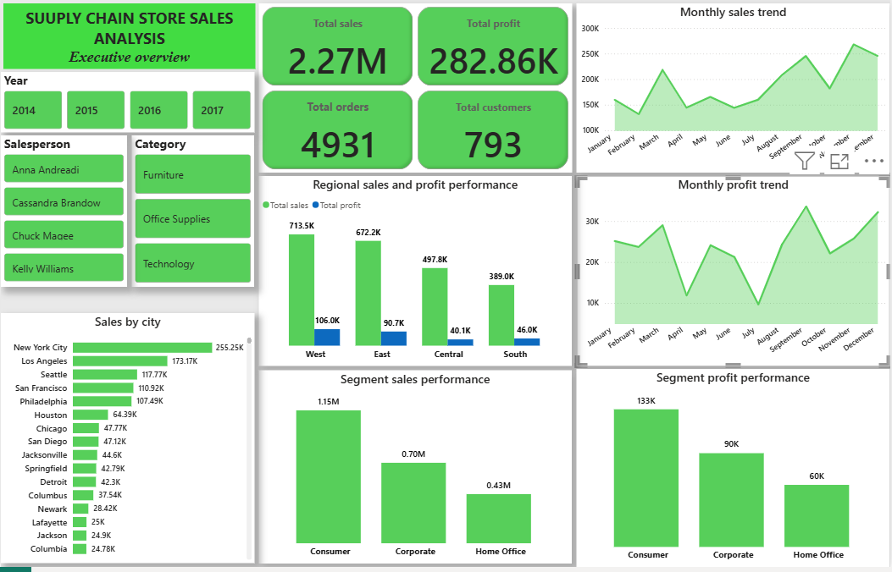
Figure 1: Supply chain sales dashboard - Executive overview

Summary of Key Findings
- Total sales were $2.27 million and total profit was $282.86 thousand with an overall profit margin of 12.45%.
- Technology generated the highest sales and absolute profit.
- Furniture generated substantial sales but had the weakest category margin at 2.32%.
- West region recorded the strongest regional margin at 14.86%, while Central recorded the weakest at 8.06%.
- Consumer generated the highest sales and absolute profit, while Home Office recorded the highest segment margin.
- Discounts above 20% were associated with negative profitability across the three customer segments.

CHAPTER FIVE: SUMMARY, CONCLUSIONS AND RECOMMENDATIONS

Summary of Findings
The project analyzed 9,994 retail transaction records covering 2014–2017. The analysis evaluated sales, profit and margin across categories, regions and customer segments and examined the association between discount levels and profitability.
The results show substantial differences in profitability across business dimensions. Technology was the strongest category by sales and absolute profit, while Furniture produced a much lower margin despite substantial sales. Consumer was the largest segment by sales and absolute profit, while Home Office recorded the highest margin. West was the strongest region by profit margin, while Central had the weakest.

Conclusions
The analysis demonstrates that sales volume alone is not sufficient for evaluating retail business performance. Profit and profit margin provide additional information about how effectively revenue is converted into earnings.
The observed relationship between discount levels and profitability suggests that discounting should be evaluated together with profit rather than sales alone. Because this is an observational analysis, the results should be interpreted as associations rather than proof of causation.

Recommendations
- Strengthen discount controls by setting a 20% review threshold.
Management should review and restrict discounts above 20% since the analysis shows that profitability remained positive up to the 11–20% discount band but became negative from the 21–30% band across all customer segments. Discounts above this level should therefore require justification based on expected sales value and profitability.
- Improve the profitability of the furniture category.
Furniture generated substantial sales but recorded only a 2.32% profit margin, considerably below technology (17.39%) and office supplies (17.13%). Management should prioritize improving furniture margins by reducing excessive discounting and reviewing pricing and product-level profitability, particularly for transactions receiving discounts above 20%.
- Prioritize margin improvement in the Central region.
Central recorded the lowest regional profit margin at 8.06% compared with 14.86% in the West, 13.49% in the East, and 11.83% in the South. Management should apply tighter pricing and discount controls in Central and prioritize sales activities that generate stronger profit margins rather than focusing solely on sales volume.
- Adopt profitability-based discounting rather than volume-based discounting.
Discount decisions should consider the expected profit contribution of each transaction instead of focusing only on increasing sales. The analysis shows that higher discount bands are associated with increasingly negative profitability indicating that additional sales generated through deep discounts may not always translate into additional profit.
- Prioritize high-margin customer segments while protecting sales volume.
The home office segment recorded the highest profit margin at 14.05%, followed by corporate at 12.97%, while consumer generated the highest sales and absolute profit but had the lowest margin at 11.53%. Management should maintain consumer’s sales volume while applying measures to improve its margin, and use the stronger-margin home office and corporate segments as opportunities for profitable growth.

